READ ME FIRST

Overview:
This should provide a good guide on what you are looking at in terms of how the file tree is organized for easy usage.

Step One –
Excel File
- Variable Description & TTest
This is essentially a redone version of the May 13th results Excel sheet with the ttests, and a redone version of the data key I sent with the previous data. All ttests that we previously ran (except for individual plot level data as we decided it was not helpful) are included in this and UPDATED. The good thing is the majority stayed significant that were previously and more are actually significant after making the corrections. I did not run the regressions because I don’t know where we are right now with those and what is wanted.

Step Two –
When you open the file titled “Files” you will see the following

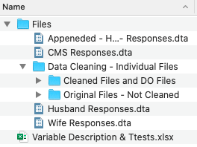

STATA FILES
- Appended – Husband Wife – Responses.dta
This is a Stata file containing all of the cleaned results for both the Husband and Wife responses. This is to be used for simple hypothesis testing. When running hypothesis testing please utilize the Respondent variable as it will determine the Husband and Wife observations (they are labeled). Example: ttest planted, by(Respondent)
- CMS Responses.dta
This is a Stata file that contains the entire CMS data base cleaned in the same way the Husband and Wife results were cleaned. This may allow for other observations if interested. Please remember, there are both men and women in this data set.
- Husband Responses.dta
This is a file that contains ONLY the husband results. The variables in this file are the same as you will find in the Wife Responses.dta file and the Appended – Husband Wife – Responses.dta file in terms of name, ordering, and labeling. Please remember, there are only the husbands responses here that have been matched to the households in the Spouse data set.
- Wife Responses.dta
This is a Stata file containing ONLY the wife results. The variables in this file are the same as you will find in the Husband Responses.dta file and the Appended – Husband Wife – Responses.dta file in terms of name, ordering, and labeling. Please remember, there are only the wives responses.

Folders
Data Cleaning – Individual Files
- Cleaned Files and DO Files
If you open this folder you will see the following:

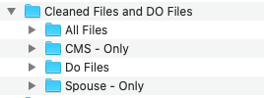
- All Files
  - Under all files you will find all of the INDIVIDUALLY cleaned Stata files of the data that have been combined for the files previously discussed. They have the same beginning file name but end with either _CMS or _Spouse to indicate which data family they come from.
- CMS – Only
  - Under this folder you will find the cleaned CMS files, and only cleaned CMS files. They are the same files that are in All Files but simply separated here for quick access if you only want to see CMS related data. They end in _CMS.
- Do Files
  - These are the DO files used to create the cleaned data files. You can open them for easy reference as to how the variables were created/cleaned.
- Spouse – Only
  - Under this folder you will find the cleaned Spouse files, and only cleaned Spouse files. They are the same files that are in All Files but simply separated here for quick access if you only want to see Spouse related data. They end in _Spouse. Please remember, these data sets will only contain the observations from the WIVES

- Original Files – Not Cleaned
If you open this folder you will see the following:

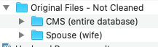

- CMS (entire database)
  - These are all of the original files obtained from Tesfa and Bela with their original file names, nothing has been edited from them. These files are the CMS files.
- Spouse (wife)
  - These are all of the original files obtained from Tesfa and Bela with their original file names, nothing has been edited from them. These files are the Spouse subset files.

